Meditation dodekaheadron

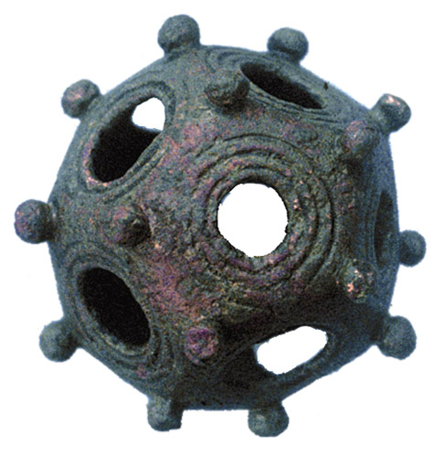

Links:
google search
http://www.dodecahedron.us/Dodecahedron.html

